Upayan De, CSE UG3, JU
Formal Languages and Automata Theory PYQs
Ans.
• Assume that a given Regular Language L is defined by a Regular Expression E. • We will show that there exists a Regular Expression E^{R}such that L (E^{R}) = (L (E))^{R} • This can be done by Mathematical Induction.
• Basis: If E is ϵ ∅, or a where a is any symbol of the alphabet. In this case, E^{R} = E. This is because { }ϵ^{R} = { }, {} ϵ^{R} = {} and {a}^{R} = {a}.
• Induction: There are three cases depending on the form of E:
1. E = E₁ + E₂ E ⇒^{R} = E₁^{R} + E₂R
2. E = E₁E₂ E ⇒^{R} = E₂^{R}E₁R
3. E = (E₁)* E ⇒^{R} = (E₁^{R})*
• Thus, by Mathematical Induction, L^{R} is Regular.
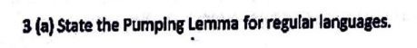Ans.
• Let L be a Regular Language. Then,
• There exists a constant n (which depends on L), such that
• For every string w in L with |w| ≥ n,
• There exists a partition of w into three strings, w = xyz such that
◦ y ≠ ϵ
◦ |xy| ≤ n
◦ For all k ≥ 0, xy^{k}z is also in L.
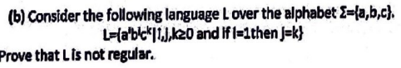Ans.
• We assume L is Regular.
• Let F be the Regular Language defined by the Regular expression a(b + c)* • Let L’ = L ∩ F. It is clear that L’ = {ab^{k}c^{k}, k ≥ 0}.
• Since the intersection of two Regular Languages is Regular, L’ must be Regular. • Thus, there exists a constant n satisfying the conditions of the Pumping Lemma for L’. • Let w = ab^{n}c^{n}. It is clear that w is in L’, and |w| ≥ n.
• By the Pumping Lemma, we can break w = xyz, such that y ≠ ϵ and |xy| ≤ n. • Since |xy| ≤ n, it is clear that xy contains only a and b’s, and does not contain c. • Case 1: (x = ab^{p}, y = b^{q})
◦ Here p ≥ 0 and q > 0.
◦ Consider the string xy⁰z. By the Pumping Lemma, this string must belong to L’. ◦ However, this string is of the form ab^{n – q}c^{n}, since y was removed.
Upayan De, CSE UG3, JU
◦ y ≠ q ≠ 0 n – q ≠ n. So the given string does not belong to L’. ϵ ⇒ ⇒
• Case 2: (x = , y = ab ϵ^{p})
◦ Here p ≥ 0.
◦ Consider the string xy⁰z. By the Pumping Lemma, this string must belong to L’. ◦ However, this string is of the form b^{n – p}c^{n}, which does not contain a.
◦ Clearly, this string does not belong to L’.
• Thus, we arrive at a contradiction, which proves that our initial assumption was false. So L is not Regular.
Ans.
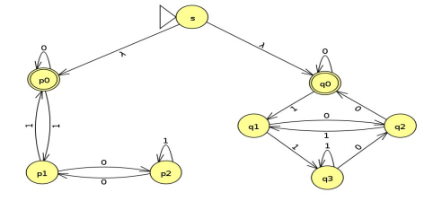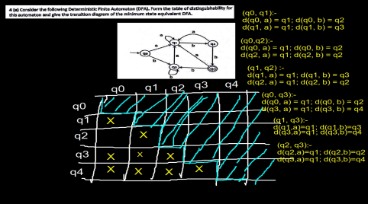
Upayan De, CSE UG3, JU
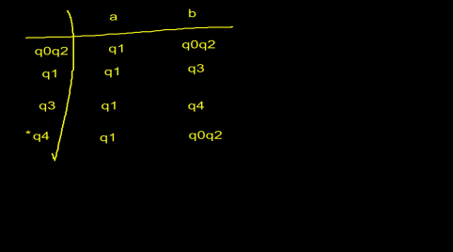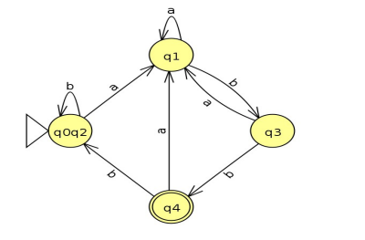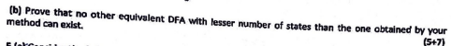Ans.
• Let the minimised DFA obtained by the table-filling algorithm be M. It follows that every state in M is distinguishable from every other state in M.
• Let us assume that there exists a DFA N, such that L(M) = L(N), and N has fewer states than M.
• The start states of M and N are indistinguishable, since L(M) = L(N).
Upayan De, CSE UG3, JU
• Now, if {p, q} are indistinguishable, then their successors on any one input symbol are also indistinguishable. If not, we could distinguish p from q.
• Neither M nor N have an inaccessible state. If so, we could simply remove that state and obtain an even smaller DFA for the same language.
• Now, we claim that every state in M is indistinguishable from at least one state in N. • Proof:
◦ Let p be a state of M.
◦ Then there is some string a₁a₂a₃...a_{n} which takes the start state of M to state p. ◦ The above string takes the start state of N to some state. Let this state be q. ◦ Since the start states of M and N are indistinguishable, it follows that their respective successors on input a₁ are also indistinguishable.
◦ The successors of these states on input a₂ are also indistinguishable, and so on until we conclude that p and q are indistinguishable.
• Since M has fewer states than N, it follows that there are at least two states in M which are indistinguishable from the same state in N, by the Pigeonhole Principle. • In that case, these two states in M are indistinguishable from each other. • However, this is a contradiction due to the design of the DFA M.
• Thus, our assumption was wrong, and such a DFA N cannot exist.
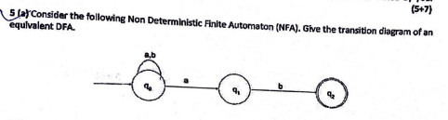Ans
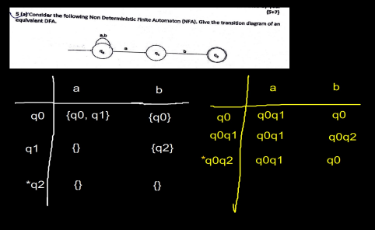
Upayan De, CSE UG3, JU
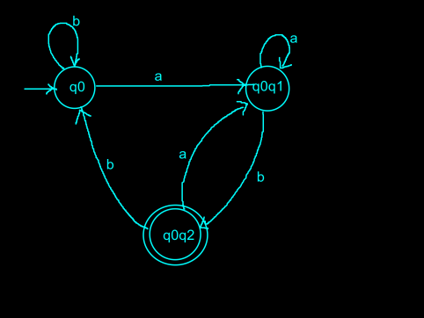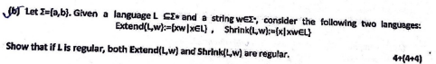Ans
• Let R be the RE which defines the language L.
• Then, the RE Rw defines the language Extend(L, w).
• This is because the language defined by the RE w is {w}, as w consists of symbols of the alphabet only, and no operator.
• Hence, Extend(L, w) is regular.
Ans.
• Let L be a Context-Free Language. Then,
• There exists a constant n (which depends on L), such that
• For every string z in L with |z| ≥ n,
• There exists a partition of z into five strings, z=uvwxy, such that
◦ vx ≠ ϵ
◦ |vwx| ≤ n
◦ For all i ≥ 0, uv^{i}wx^{i}y is also in L.
Upayan De, CSE UG3, JU
Ans.
• Assume that L is a CFL.
• Thus, there exists a constant n satisfying the conditions of the Pumping Lemma for CFLs • Let z = a^{n}b^{n}a^{n}b^{n}. It is clear than z is in L, and |z| ≥ n.
• By the Pumping Lemma, we can break z=uvwxy such that vx ≠ ϵ and |vwx| ≤ n • Since |vwx| ≤ n, there can only be two cases:
• Case 1: vwx consists of only one kind of symbol
◦ Consider the string uv⁰xw⁰y. By the Pumping Lemma, this string must be in L. ◦ However, the above string has n occurrences of three symbols and less than n of the fourth symbol, since vx ≠ . ϵ
◦ Thus, the string cannot belong to L.
• Case 2: vwx straddles two different symbols
◦ Assume that vwx straddles the second block of b’s and the first block of a’s. ◦ Consider the string uv⁰xw⁰y. By the Pumping Lemma, this string must be in L. ◦ However, the above string is missing either some a’s or some b’s or both, since vx ≠ . ϵ ◦ If the string is missing a’s, then it cannot be in L because the second block of a’s is of length n.
◦ If the string is missing b’s, then it cannot be in L because the first block of b’s is of length n.
◦ Similar arguments can be made for all other cases where vwx straddles two symbols. • Thus, our assumption was wrong and L is not a CFL.
Ans.
• We will prove this using Induction on the length of the string |w|.
• Basis:
◦ When |w| = 1, the derivation must be of the form G w. ⇒
◦ Since there are no -derivations in a CNF grammar, so if the first derivation is of the ϵ form G AB, then the length of the terminal string will exceed 1. ⇒
◦ The number of steps in the derivation = 1 = 2(1) – 1. So the basis is proved. • Induction:
◦ Assume that the hypothesis holds for all strings of length < n.
◦ Let |w| = n. Let w = a₁a₂...a_{n}.
◦ The derivation must be of the form G AB a ⇒ ⇒ ₁B where B * a ⇒ ₂a₃...an
◦ The length of the string derived by B = n – 1. Therefore, by the Induction hypothesis, this derivation takes exactly 2(n – 1) – 1 = 2n – 3 steps.
◦ Since two more steps are required to derive w, total number of steps to derive w = 2n – 3 + 2 = 2n – 1.
◦ Thus, the induction is proved.
Upayan De, CSE UG3, JU
Ans
• The CFG for the language L is given by G = (V, T, P, S) where,
• V = {S, A}
• T = {0, 1, 2, 3}
• P is the set of productions as follows:
S → 0S333 | 0A333
A → 1A2 | 12
• S is the start state.
Ans. All binary strings that do not contain two consecutive 1’s.
Ans. C
• (A) Σ* is a superset of every language
• (B) is a subset of every language ϕ
• (C) 0^{n}1^{n} is a subset of Σ*
• (D) Finite languages are regular
Ans.
• Let us assume that CFLs are closed under set intersection.
• Consider the languages
◦ L₁ = {a^{x}b^{x}c^{y}, x ≥ 1, y ≥ 1}
◦ L₂ = {a^{x}b^{y}c^{y}, x ≥ 1, y ≥ 1}
• A Context-Free Grammar for L₁ is given by the productions
S → AB
A → aAb | ab
B → Bc | c
Thus, L₁ is a CFL.
• A Context-Free Grammar for L₂ is given by the productions
S → AB
Upayan De, CSE UG3, JU
A → aA | a
B → bBc | bc
• The language L = L₁ ∩ L₂ is then given by {a^{x}b^{x}c^{x}, x ≥ 1}
• By our assumption, L must also be a CFL.
• However, L is not a CFL, which can be proved using the Pumping Lemma for CFLs. • We arrive at a contradiction. So, our initial assumption is incorrect, and CFLs are not closed under set intersection.
Proof that L is not a CFL
• Assume L is a CFL.
• Thus, there exists a constant n (depending on L) satisfying the conditions of the Pumping Lemma for CFLs.
• Let z = a^{n}b^{n}c^{n}. It is clear that w is in L and |w| ≤ n.
• By the Pumping Lemma, we can break z = uvwxy, such that vx ≠ ϵ and |vwx| ≤ n. • Since |vwx| ≤ n, there are two cases:
• Case 1: vwx contains only one kind of symbol, say a
◦ Consider the string uv⁰wx⁰y.By the Pumping Lemma, this string must belong to L. ◦ However, the string has n occurrences of b and c and < n occurrences of a. ◦ vx ≠ , so at least one occurrence of ϵ a was dropped.
◦ Thus the string cannot belong to L.
• Case 2: vwx straddles two symbols say a and b
◦ Consider the string uv⁰wx⁰y.By the Pumping Lemma, this string must belong to L. ◦ However, the string has n occurrences of c and < n occurrences of either a or b or both. ◦ vx ≠ , so at least one occurrence of either ϵ a or b was dropped.
◦ Thus the string cannot belong to L.
• We see that, in all the cases we arrive at a contradiction.
• So, our initial assumption was wrong, and L is not a CFL.
Ans.
• R – C = R ∩ C’
• We know that the complement of a CFL may or may not be a CFL.
• Case 1: C’ is a CFL
◦ We know that the intersection of a RL and a CFL is a CFL.
◦ Thus R – C is a CFL.
• Case 2: C’ is not a CFL
◦ In this case, we cannot determine whether R – C is a CFL.
Ans.
• Let M be a Turing Machine.
• Let H(M) denote the set of input strings w such that
◦ M halts given input w, regardless of whether it accepts w or not.
• The Halting Problem is then the language defined by the set of all pairs (M, w) such that w is in H(M).
• This language is RE but not Recursive.
Upayan De, CSE UG3, JU
Ans.
Ans.
• P: We say a language L is in class P if
◦ There exist some deterministic Turing Machine M and some polynomial T(n) such that ▪ L = L(M)
▪ When M is given any input of length n, there are no sequences of more than T(n) moves of M.
◦ Eg: Kruskal’s Algorithm, Sorting Problem
• NP: We say a language L is in class NP if
◦ There exist some non-deterministic Turing Machine M and some polynomial T(n) such that
▪ L = L(M)
▪ When M is given any input of length n, there are no sequences of more than T(n) moves of M.
◦ Eg: Travelling Salesman Problem
• NP-Hard: We say a language L is NP-hard if
◦ For every language L’ in NP, there is a polynomial time reduction of L’ to L. ◦ We cannot prove that L is in NP.
◦ Eg: Subset Sum Problem
• NP-Complete: We say a language L is NP-complete if
◦ For every language L’ in NP, there is a polynomial time reduction of L’ to L. ◦ L is in NP.
◦ Eg: SAT (Boolean Satisfiability)
Ans.
Upayan De, CSE UG3, JU
• Here the Turing Machine is given by M = ({q₀, q₁, q₂}, {0, 1}, {0, 1, B}, δ, q₀, B, {q₂}) • δ is defined by the above transition diagram.
Ans.
• To prove a problem H is NP-hard, we show that there is a polynomial time reduction from a known NP-hard problem (such as SAT) to H.
• To prove that a problem H is NP-complete we
◦ Prove that H is NP-hard as described above.
◦ Show that H is in NP, by providing a suitable polynomial time non-deterministic algorithm to solve the problem.
Ans.
• We will prove this using Induction on n.
• Basis: n = 1
◦ In this case, the Parse tree contains just the root and one leaf node.
◦ The terminal symbol at the root node must be w. So |w| = 1 ≤ 2^{1 – 1}.
• Induction: n ≥ 2
◦ Assume the inductive hypothesis holds for all parse trees with length of longest path < n. ◦ The production at the root of the tree must be of the form A → BC, since this is not the last level.
• The longest path in the subtrees rooted at B and C ≤ n – 1, since the edge from A to B or A to C is excluded.
• Thus using the Inductive Hypothesis, the yields of the subtrees rooted at B and C have length ≤ 2^{n – 1 – 1} = 2^{n – 2}.
• Since the yield of the Parse tree rooted at A is a concatenation of the yields of subtrees B and C, |w| ≤ 2^{n – 2} + 2^{n – 2} = 2^{n – 1}.
Ans.
• For every context free language L
Upayan De, CSE UG3, JU
• There exists a constant n (depending on L) such that
• For every string z in L, such that |z| ≥ n,
• There exists a partition of z into five strings uvwxy, such that
◦ vx ≠ ϵ
◦ |vwx| ≤ n
◦ For all i ≥ 0, uv^{i}wx^{i}y is in L.
• Assume L is a CFL.
• Thus there exists a constant n satisfying the conditions of the Pumping Lemma for CFLs. • Let z = 0^{n}1^{n}0^{n}1^{n}. It is clear that z is in L, and |z| ≥ n.
• By the Pumping Lemma, we can break z = uvwxy such that vx ≠ and |v ϵ wx| ≤ n. • Also by the Pumping Lemma, uv⁰wy⁰x = uwy must be in L.
• Since |vwx| ≤ n, so |uwy| ≥ 3n. If uwy = tt, then |tt| ≥ 3n / 2.
• There are many cases to consider depending on the position of vwx:
• Case 1: vwx is in the first block of 0’s:
◦ Let vx consist of k 0’s, k > 0 as vx ≠ . ϵ Now, the string is of the form 0^{n – k}1^{n}0^{n}1^{n}. ◦ |uwy| = 4n – k. If uwy = tt, then |t| = 2n – k / 2 > 2n – k.
◦ So, t does not end until after the first block of 1’s.
◦ So, t ends in a 0. However uwy ends in a 1. So uwy ≠ tt for any string t. • Case 2: vwx straddles the first block of 0’s and 1’s
◦ If vx contains only 0’s (x = ), then the argument is the same as Case 1. ϵ ◦ If vx contains at least one 1, then the first block of 1’s has length < n.
◦ uwy ends with a string of n 1’s. If uwy = tt, then t must also end with n 1’s. ◦ But there is only one block on n 1’s in uwy. So uwy ≠ tt for any t.
• Case 3: vwx is in the first block of 1’s
◦ The argument is the same as the second part of Case 2.
• Case 4: vwx straddles the first block of 1’s and the second block of 0’s ◦ If vx contains only 1’s (x = ), then the argument is the same as the second part of Case 2 ϵ ◦ If vx contains at least one 0, then the second block of 0’s has length < n. ◦ uwy begins with a block of n 0’s. If uwy = tt, then t must also begin with n 0’s. ◦ But there is only one block of n 0’s in uwy. So uwy ≠ tt, for any t.
• Symmetric arguments can be made for the remaining cases.
• Thus in all the cases, we arrive at a contradiction. So our assumption is wrong, and L is not a CFL.
Upayan De, CSE UG3, JU
Upayan De, CSE UG3, JU
Upayan De, CSE UG3, JU
Upayan De, CSE UG3, JU
Upayan De, CSE UG3, JU
Upayan De, CSE UG3, JU
Ans.
• Assume L is a CFL.
• Thus, there exists a constant n (depending on L) satisfying the conditions of the Pumping Lemma for CFLs.
• Let p, q be distinct prime numbers ≥ n. We are guaranteed that such primes exist since there are infinitely many primes.
• Let z = 0^{p.q}. Clearly, z is in L, and |z| = pq ≥ n.
• By the Pumping Lemma, we can break z = uvwxy such that vx ≠ and |vwx| ≤ n. ϵ • Let |vx| = m > 0.
• Let k = pq + 1. Consider the string t = uv^{k}wx^{k}y. By the Pumping Lemma, this string must be in L.
• Since the string consists of only 0’s,
|t| = |uwy| + k|vx| = pq – m + km = pq + (k – 1)m = pq(1 + m)
• Since, 1 + m > 1, |t| has at least three factors p, q and (1 + m). So, it cannot be the product of two primes.
• Hence t does not belong to L, which is a contradiction.
• So, our assumption was wrong and L is not a CFL.
Upayan De, CSE UG3, JU
Upayan De, CSE UG3, JU
Upayan De, CSE UG3, JU
Ans.
• If L is the language of a finite automaton
◦ We check if there is any state p reachable from the start state such that p is a final state. ◦ This can be done using a recursive depth-first search algorithm for graph reachability. ◦ If no such p exists, L is empty. Otherwise L is non-empty.
• If L is given by a Regular Expression R.
◦ We proceed by Induction.
◦ Basis: is empty. ϕ
◦ Induction:
▪ R = R₁ + R₂ is empty iff R1 and R2 are both empty.
▪ R = R₁R₂ is empty iff either R1 or R2 or both are empty.
▪ R = R₁* is never empty.
▪ R = (R₁) is empty iff R₁ is empty.
Ans.
• We define a state (q_{L}, q_{M}) of the product DFA to be accepting iff exactly one of q_{L} and q_{M} is an accepting state.
• That is, either q_{L} is final or q_{M} is final but not both.
• If the language accepted by the above DFA is empty, we can conclude that L = M.
Ans.
E^{R} = (01* + 10*)^{R} = (01*)^{R} + (10*)^{R} = 1*0 + 0*1
Ans.
• Given, there exists a string of length ≥ n in L(A).
• Let this string be w.
• If n ≤ |w| < 2n, then the claim is trivially true.
• Let |w| = m ≥ 2n.
• Let w = a₁a₂...a_{m}, where a_{i} is a symbol in Σ.
• Let p₀ be the start state. We define p_{i} to be the state δ(p₀, a₁a₂...a_{i}). That is p_{i} is the state of the DFA after processing the first i symbols of w.
• Clearly p_{m} is a final state, since w is in L.
• Now, the total number of states p_{0,} p_{1,} ... p_{m} = m + 1 ≥ 2n + 1 > n.
• Since the DFA has only n states, by the Pigeonhole Principle, at least two of these states must be the same.
• Let p_{i,} p_{j} (i < j) be two states such that p_{i} = p_{j} and (j – i) is the smallest possible. • It is clear then that p_{i}, p_{i + 1}, ... p_{j – 1} must be distinct states (otherwise we have a choice of i, j that gives a smaller j – i).
• Since the total number of states in the DFA = n, we conclude that j – i ≤ n.
Upayan De, CSE UG3, JU
• Since p_{i} = p_{j}, we can say that the string t = a₁a₂...a_{i}a_{j + 1}a_{j + 2}...a_{m} takes the start state of the DFA to the same final state p_{m}.
• |t| = |m| - (j – i). Since |m| ≥ 2n and 0 < (j – i) ≤ n, we can say n ≤ |t| < |m|. • Thus, we have proved that for every string w of length ≥ 2n in L, there exists a strictly shorter string t in L with |t| ≥ n.
• We apply this process of shortening repeatedly starting from our initial string w, until we obtain a string with length in [n, 2n – 1], which terminates in a finite number of steps.
Upayan De, CSE UG3, JU
Ans.

